12.6 Surface Area and Volumes of Spheres

Prisms (Cylinders)  LA =  SA =  V = | Pyramids (Cones)  LA =  SA =  V =
Shperes  SA =  V = | Hemispheres  LA =  SA =  V =

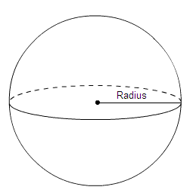

Find surface area and volume of each sphere.

1.) | 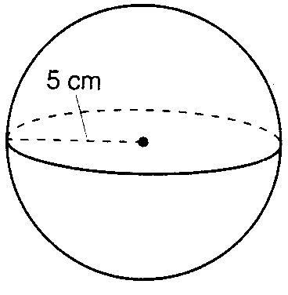  Surface Area:  Volume:

2.) | 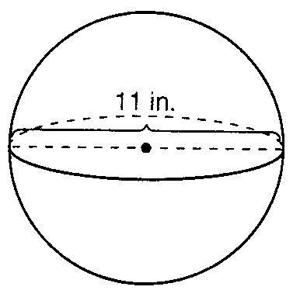  Surface Area:  Volume:

