12.5 Volume of Pyramids and Cones

Find the lateral area, surface area and volume of each pyramid or cone.

1.) | A hexagonal pyramid with base sides 4 meters and height 8 meters.  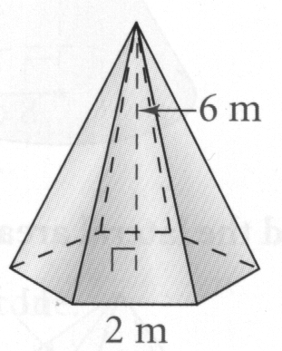  Lateral Area:  Surface Area:  Volume:

2.) | A square pyramid with base sides 6 cm and slant height 9 cm  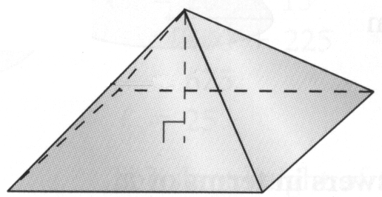  Lateral Area:  Surface Area:  Volume:

3.) | A cone with slant height 6 in. and radius 3 in.  Lateral Area:  Surface Area:  Volume:

