12.4 Volume of Prisms and Cylinders
Volume is the amount of space enclosed by an object. The volume of a prism and cylinder with a base area B and height h is

Find the exact volume of the prism.
1.) | 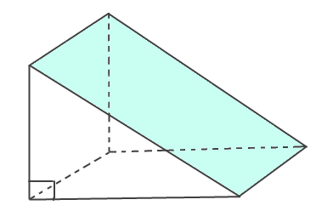  Volume:

