**12.2 Surface Area and Nets**

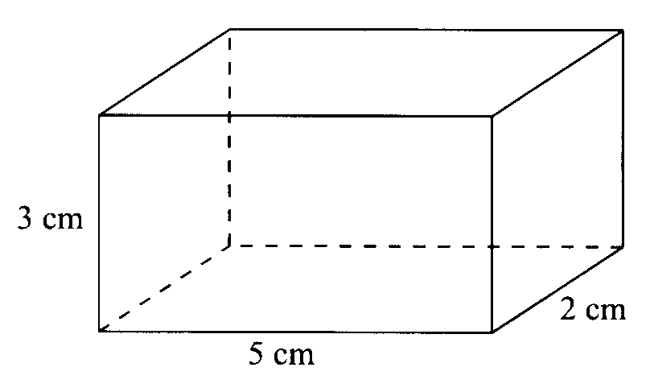

1.) Create an isometric drawing of the rectangular prism



2.) Create a net of the rectangular prism

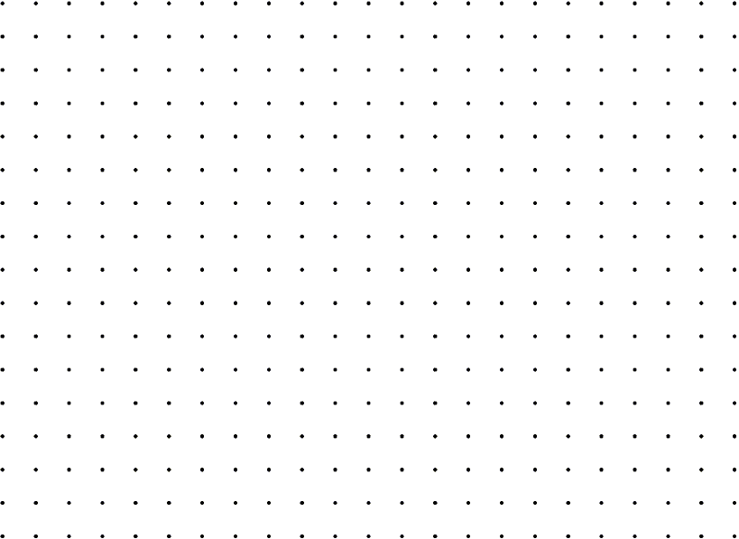

3.) Find the surface area of the rectangular prism

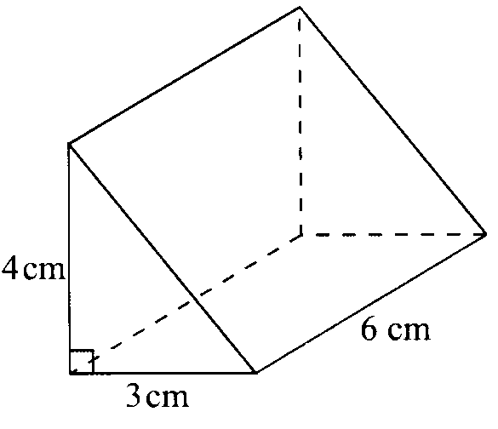

4.) Create an isometric drawing of the triangular prism



5.) Create a net of the triangular prism



6.) Find the surface area of the triangular prism

There are 11 different combinations of a cube. Create at least 6 different nets for a cube.

