12.2 Lateral Area and Surface Area of Prisms and Cylinders

Prism (Cylinder)

Pyramid (Cone)

Sphere (Hemisphere)

Polyhedron

Find the lateral and surface area of each figure.
1.) | 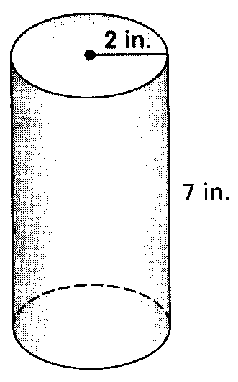  Lateral Area:  Surface Area: | 2.) | 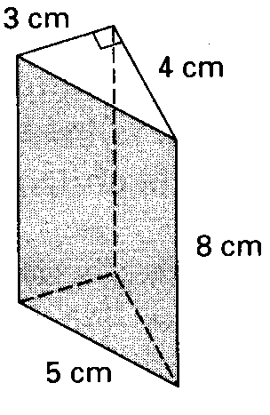  Lateral Area:  Surface Area:

3.) | 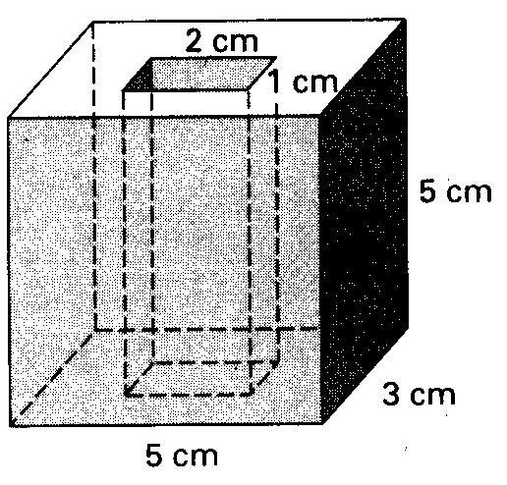  Lateral Area:  Surface Area:
4.) | 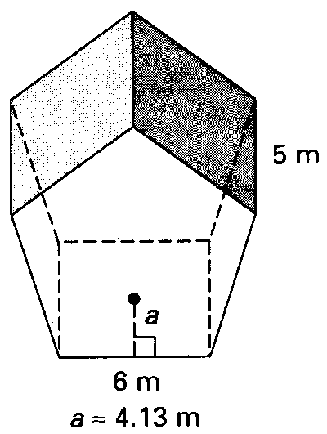  Lateral Area:  Surface Area:

