Name:

12.1 Isometric and Orthographic Drawings

Make each shape using cubes. How many cubes were used to make each shape? Create an isometric and orthographic drawing of each shape.

1.) | 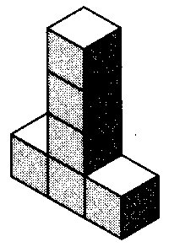 | 2.) | 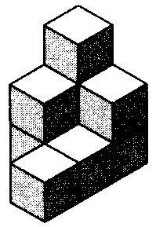
3.) | 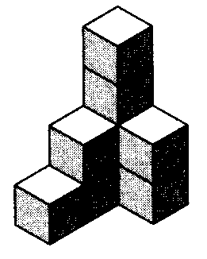 | 4.) | 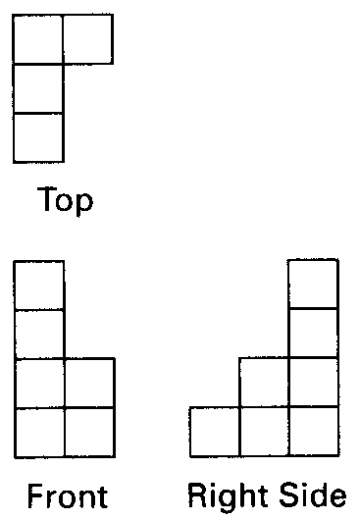
5.) | 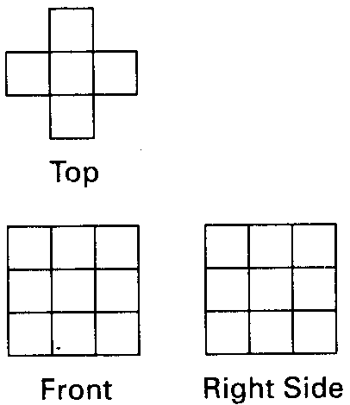 | 6.) | 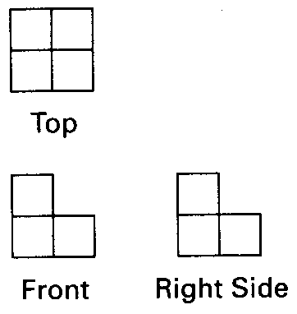
7.) |  | 8.)

