11.3 Areas of Other Quadrilaterals

Find the exact area and perimeter of the quadrilateral. Then round your answer to two decimal places.

1. | 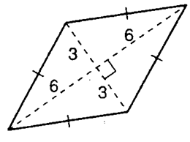  Area:  Perimeter: | 2. | 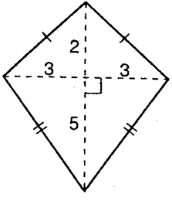  Area:  Perimeter:
3. | 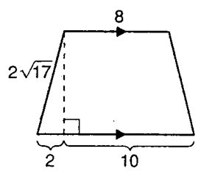  Area:  Perimeter: | 4. | 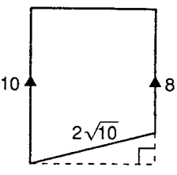  Area:  Perimeter:

The quadrilateral has an area of 64 square units. Find the value of x. Then find the perimeter of the figure.

5. | 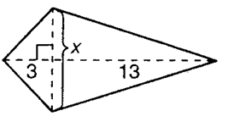  x:  Perimeter: | 6. | 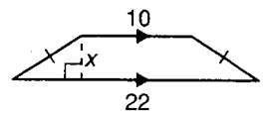  x:  Perimeter:
7. | 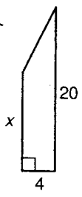  x:  Perimeter: | 8. | 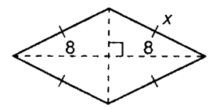  x:  Perimeter:

