11.2 Parallelograms and Triangles

Find the exact area and perimeter of the shaded region. Then round your answer to two decimal places.

1. | 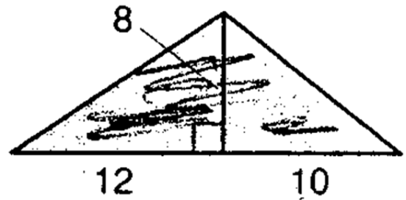  Area:  Perimeter: | 2. | 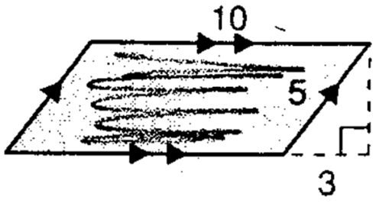  Area:  Perimeter:
3. | 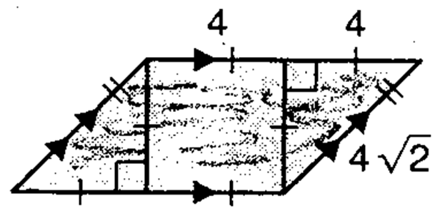  Area:  Perimeter: | 4. | 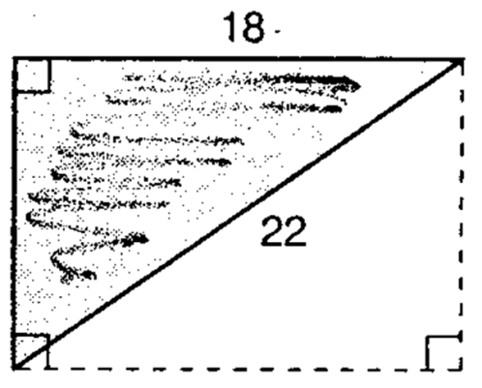  Area:  Perimeter:

5. | 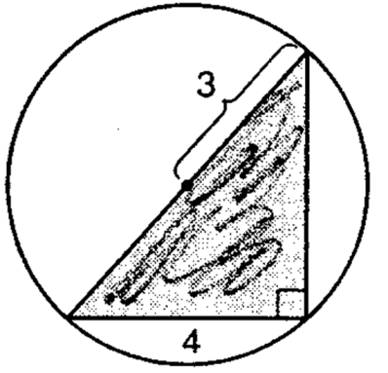  Area:  Perimeter: | 6. | 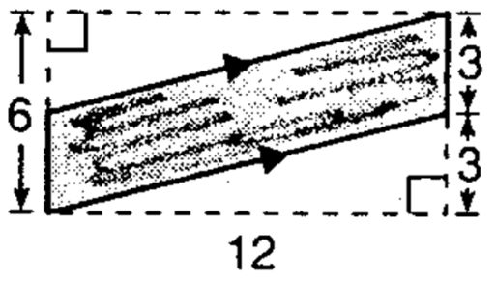  Area:  Perimeter:
7. | 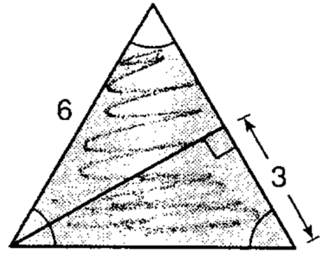  Area:  Perimeter: | 8. | 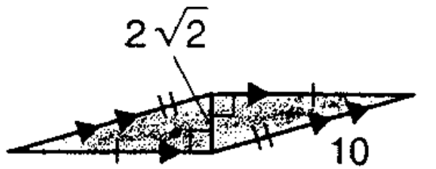  Area:  Perimeter:

