11.1 Perimeter and Area
Perimeter:

Area:

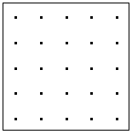

Perimeter:

Area:

Perimeter:

Area:

