5.8 Modeling with Quadratic Functions

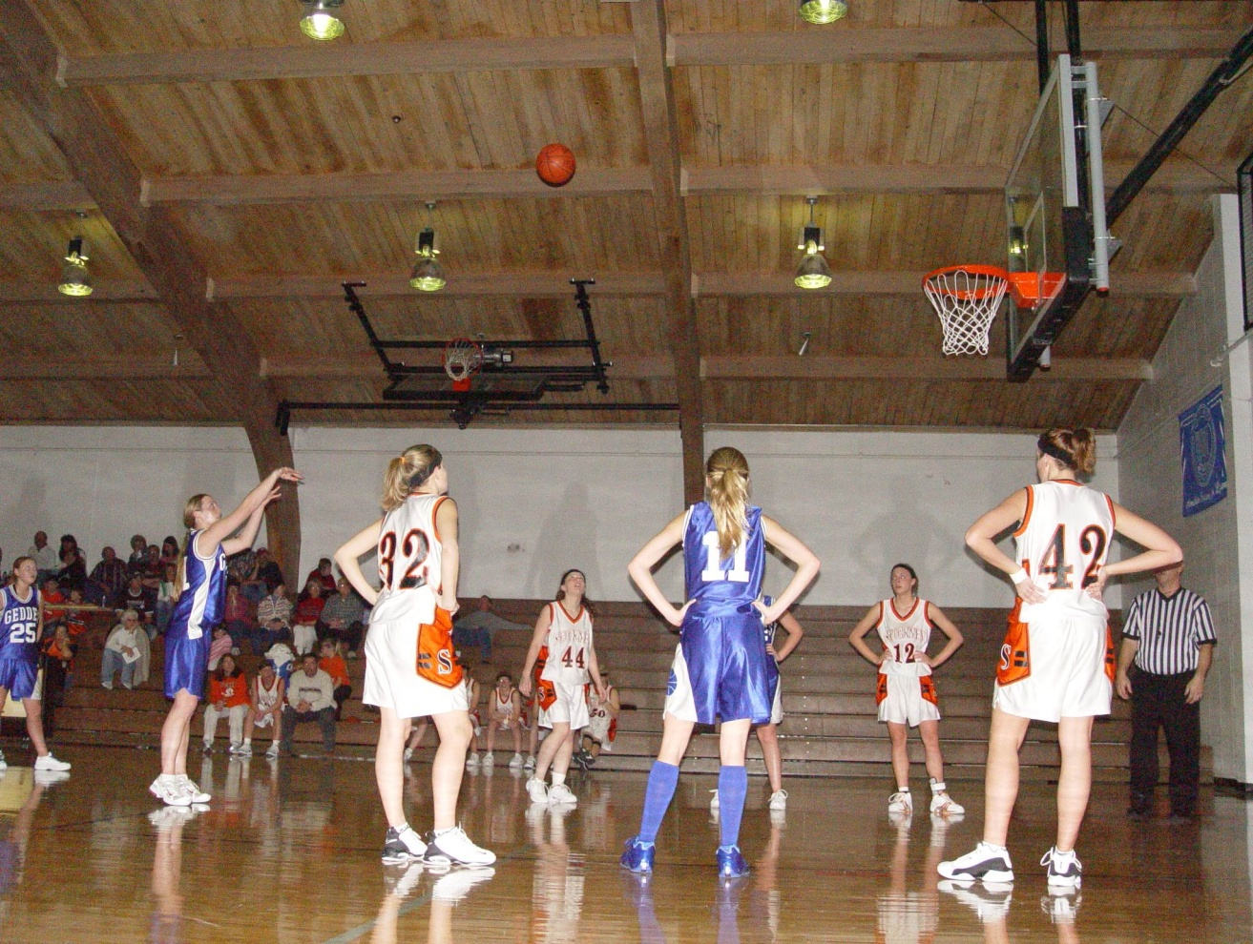

1.) Using the given information, come up with three ordered pairs that the ball will travel through.

Given information:
- The free throw is good
- Ball is 5 lateral feet away from shooter and 12 feet in the air in the picture
- Hoop is 10 feet tall and 15 feet from shooter
- Three feet after the player shot the ball, it was the same height as the hoop

2.) Due to gravity, the path of the ball will be a parabola. Using the ordered pairs from problem 1, write the equation for the path of the ball.

3.) Using the equation from problem 2, find the height of the shooter (assume the shooter’s height is the same as the height of the ball when she releases it).

4.) If the hoop was not there to stop the ball, how far away from the shooter would the ball be when it hit the ground?

