2.7 Piecewise Functions

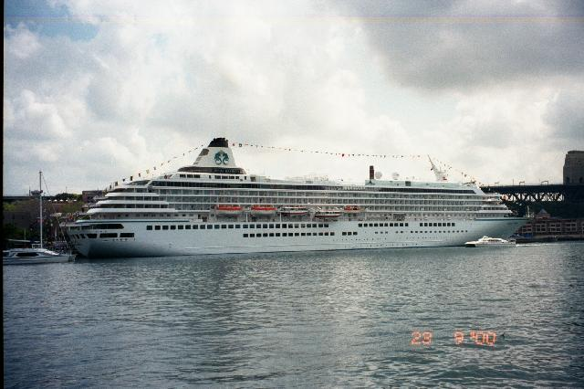

You were recently hired as summer help on an ocean line cruiser. Your job will be to scrub the boat’s deck. You start work in June and you want to know how much you will get paid each week. Since you are not allowed to bring a calculator with you (some strange rule the company enforces), you must make a graph displaying how much you will get paid compared to the number of hours that you work. You make $8 an hour with time and a half paid for any hours worked over 40 hours in a week and double time for any hours worked over 60 hours in a week. Complete the table to show how much you will make working between 0 and 100 hours (you really love your job).

Hours | 0 | 5 | 10 | 15 | 20 | 25 | 30 | 35 | 40 | 45 | 50
Pay

Hours | 55 | 60 | 65 | 70 | 75 | 80 | 85 | 90 | 95 | 100
Pay

Create a graph showing the number of hours worked verses your pay

Write an equation using function notation to represent your pay.

