2.6 Linear Inequalities in Two Variables
You and a group of your friends are planning a trip to the Mall of America to go clothes shopping. You have saved $300 for this trip. You need to buy pants and shirts on this shopping spree since your wardrobe is out of style. Pants cost $25 and shirts cost $15. Write an inequality that shows how many pants and shirts you could buy. Then graph the inequality and find three possible outcomes of pants and shirts.

Each of the following problems contains a mistake. Find the mistake, correct it and get the right answer.

1.) | y ≥ -2x + 5  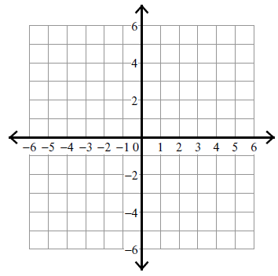
2.) | y < $\frac{7}{3}$x – 5

3.) | y > - $\frac{4}{5}$x
4.) | x – 2y < -2

