12.4 Volume of Prisms and Cylinders
1.) Make the following 3D solid out of cubes.

2.) Describe how you would find the surface area of the solid without using the surface area formula?
Hint: Think of what surface area actually is measuring…

3.) Describe how would you find the volume of the solid without using the volume formula?
Hint: Think of what volume actually is measuring…

4.) Draw the base of the solid and find the perimeter and area of the base

5.) Use the formulas to find lateral area and surface area.

6.) Use the formula to find the volume of the solid.

Volume is the amount of space enclosed by an object. The volume of a prism and cylinder with a base area B and height h is V = Bh

Find the exact volume of each figure.
1.) | 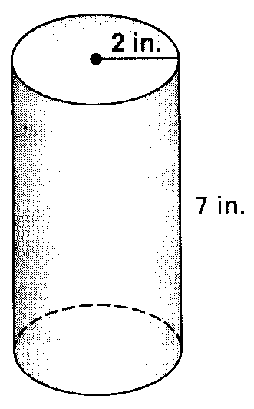  Volume: | 2.) | 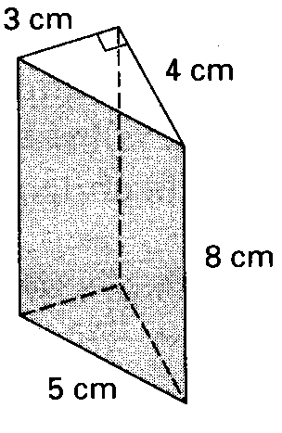  Volume:

3.) | 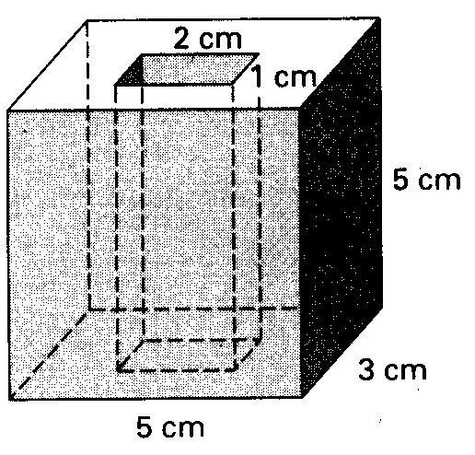  Volume: | 4.) | 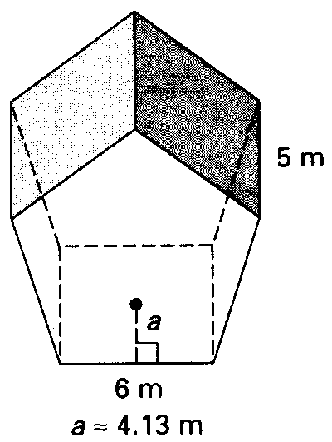  Volume:
5.) | 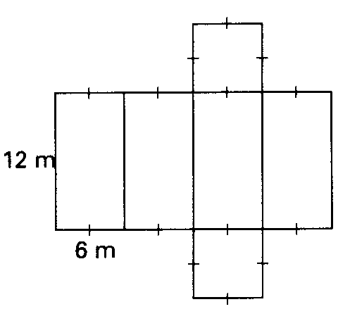  Volume: | 6.) | 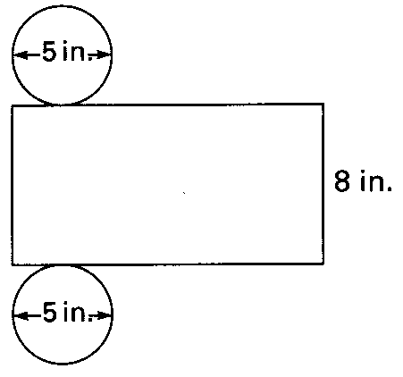  Volume:

