12.3 Lateral Area and Surface Area of Pyramids and Cones

Find the lateral area and surface area of each pyramid or cone.

1.) | A hexagonal pyramid with base sides 2 meters and height 6 meters.  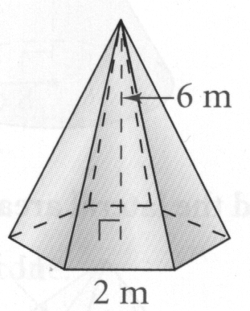  Lateral Area:  Surface Area:

2.) | A square pyramid with base sides 6 cm and height 3 cm  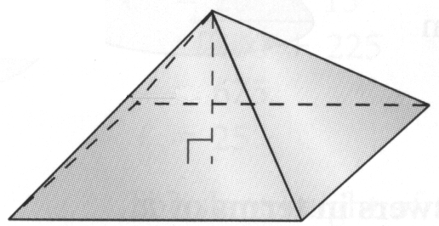  Lateral Area:  Surface Area:

3.) | A cone with height 12 in. and radius 3 in.  Lateral Area:  Surface Area:

