11.6 Compound Shapes

Find the exact area and perimeter of the shaded region.

1. | 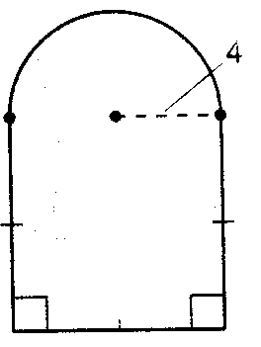  Area:  Perimeter: | 2. | Area:  Perimeter: | 3. |  | 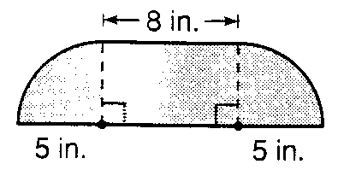  Area:  Perimeter:
4. | 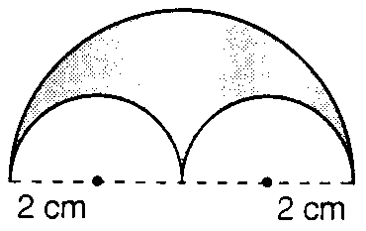  Area:  Perimeter: | 5. | 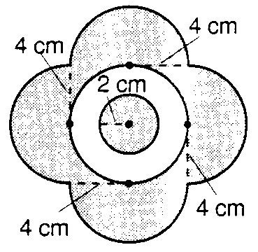  Area:  Perimeter:

