11.4 Areas of Regular Polygons

Find the exact area and perimeter of the polygon. Then round your answer to two decimal places.

1. | 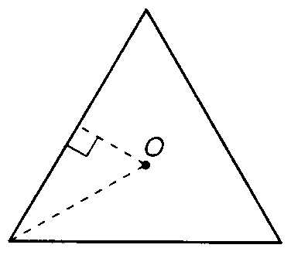  Perimeter:  Area: | 2. | 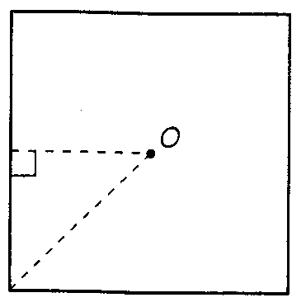  Perimeter:  Area:
3. | 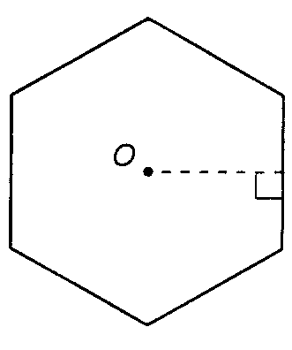  Perimeter:  Area: | 4. | Perimeter:  Area:
5. | Perimeter:  Area: | 6. | Perimeter:  Area:
7. | Perimeter:  Area: | 8. | Perimeter:  Area:

