Name:
1.4 Rewriting Formulas
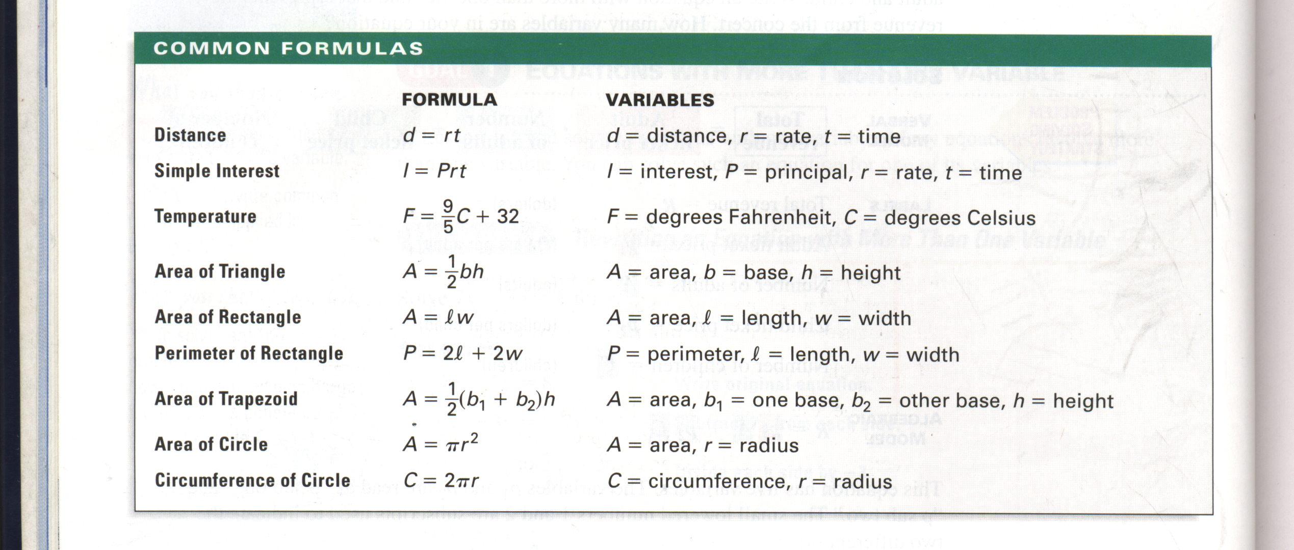
Solve the following equations for the given variable. Show your work.

1. Distance for rate | 2. Perimeter of a Rectangle for length
3. Area of a Circle for pi | 4. Simple Interest for time

5. Circumference of a Circle for radius | 6. Area of a Rectangle for width
7. Area of a Triangle for base | 8. Temperature for degrees Celsius
9. Area of a Trapezoid for height | 10. Area of a Trapezoid for base one

